**HL DENTAL CLINIC**

**G4 HighTech**

**Product Requirement Specification**

**Members**

|  |  |  |
| --- | --- | --- |
| **No.** | **Full name** |  |
| 1 | Trần Tuấn Anh |  |
| 2 | Chu Bạch Dương |  |
| 3 | Trần Ngọc Nguyên | Leader |
| 4 | Nguyễn Thị Bích Diệp |  |
| 5 | Lê Hải Anh |  |
| 6 | Trịnh Hương Ly |  |
| 7 | Nguyễn Thị Tú Bình | Deputy |

**Document Track Change**

|  |  |  |  |  |  |
| --- | --- | --- | --- | --- | --- |
| **Date** | **Purpose** | **Changes** | **Description** | **Editor** | **Version** |
| 2023/03/02 | Update |  | Update BP, UCD, UCS | Nguyên | v0.1 |
|  |  |  |  |  |  |
|  |  |  |  |  |  |
|  |  |  |  |  |  |

**TABLE OF CONTENT**

1 INTRODUCTION 2

1.1 Purpose 2

1.2 Scope 2

2 PRODUCT OVERVIEW 2

2.1 Business Process 3

2.2 Use Case Diagram 3

2.3 Overall Structure 4

2.4 Business Funcation Diagram 4

3 BUSINESS REQUIREMENT 5

3.1 Minimum Viable Product 6

4 SPECIFICATION 7

4.1 View Information 8

4.2 Online Booking 10

4.2.1 Online Booking 10

4.2.2 Online Booking Guest - Payment for Reserve 12

4.3 Manage Schedule 15

4.4 Treatment History 19

4.5 Medicine bills 20

4.7 Customer Service – Feedback 22

4.8 Customer Service – Chat/Call with us 23

4.9 Account 24

4.9.1 Account – Sign Up/Sign In 24

4.9.2 Account – change password 26

4.9.3 Account – Forget password 28

4.9.4 Account – Membership 30

4.9.5 Account – Change profile information 31

4.9.6 Account – Turn on/off notification 33

# **1 INTRODUCTION**

## **1.1 Purpose**

HL Dental Clinic Mobile App is a communication channel between customers and clinics, helping customers save time and improve when using services to increase customer experience when coming to HL Dental Clinic System.

The Product requirement specification (PRD) provides the overview of the HL Dental Mobile App system. The document will include the scope, business case, business process, use case, specification, and workflow.

## **1.2 Scope**

The purpose of this document is to give the overview requirement and specification of the HL Dental Mobile App system. The scope includes the Mobile App system.

1.3 Word definition

|  |  |  |
| --- | --- | --- |
| **No.** | **Word** | **Description** |
| 1 | HLDM | HL Dental Mobile App |
| 2 | HLDIMS | HL Dental Internal Management System |
| 3 | DD/MM/YY | Day/Month/Year |

# **2 PRODUCT OVERVIEW**

## **2.1 Business Process**

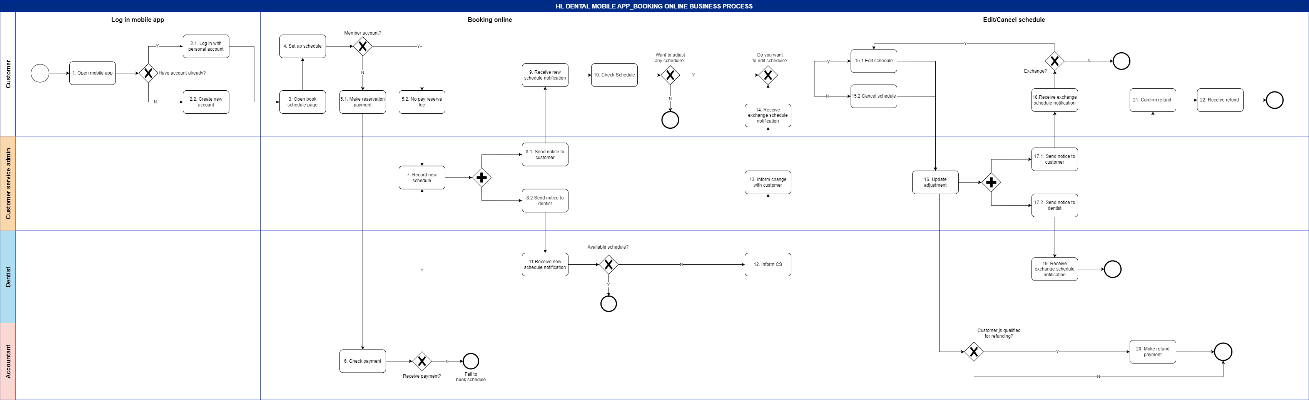

## **2.2 Use Case Diagram**

## **2.3 Overall Structure**

## **2.4 Business Funcation Diagram**

# **3 BUSINESS REQUIREMENT**

## **3.1 Minimum Viable Product**

# **3 BUSINESS REQUIREMENT**

## **3.1 Minimum Viable Product**

Link to view detail: https://miro.com/app/board/uXjVPqJ-nCc=/

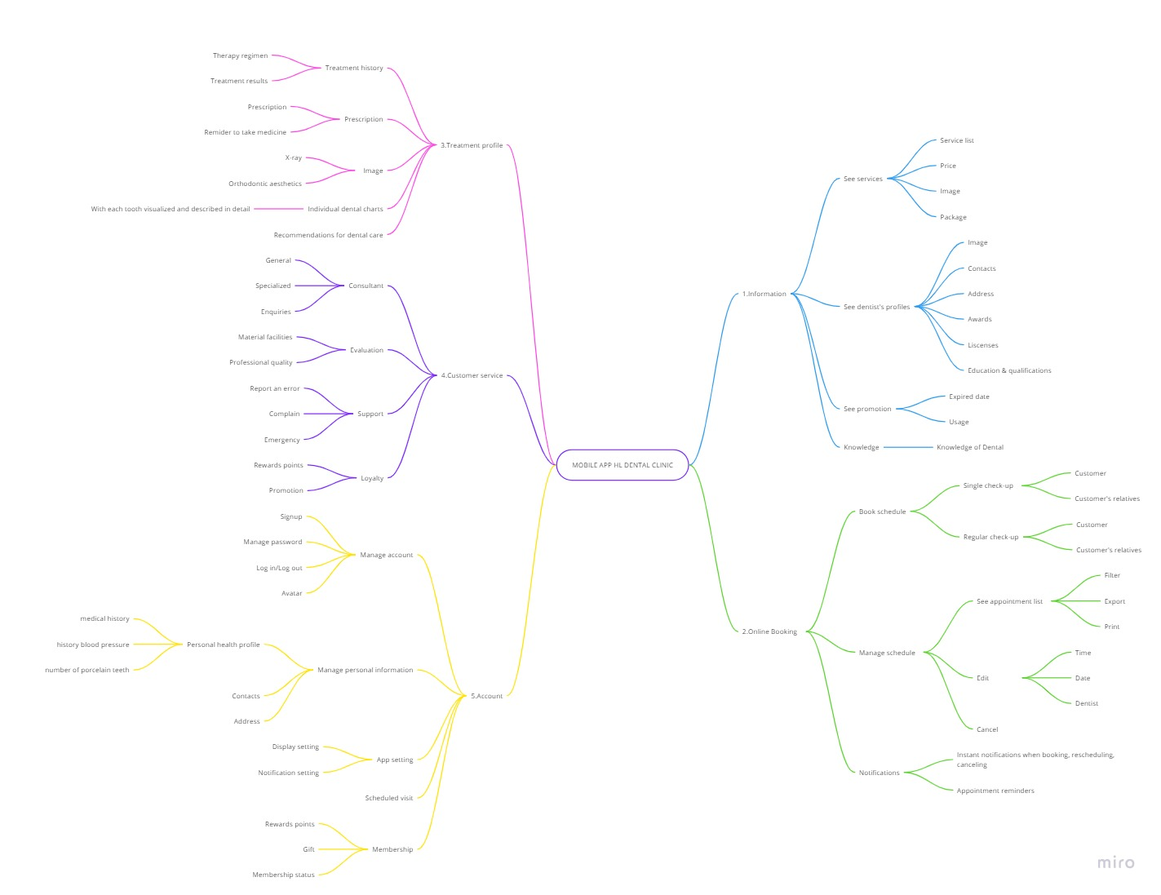

# **4 SPECIFICATION**

## **4.1 View Information**

**a) Use case diagram**

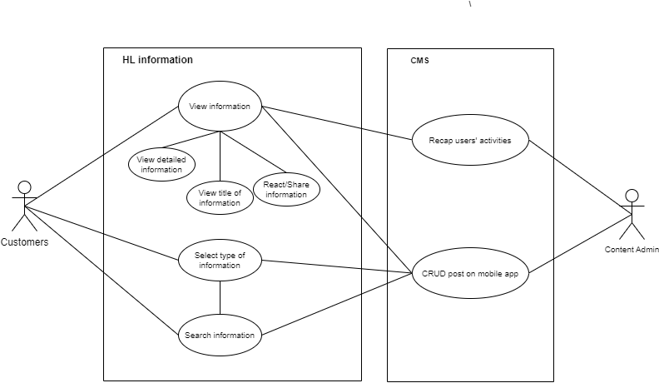

**b) Specification**

|  |  |
| --- | --- |
| **UC Name** | Search information |
| **Actor** | Customers, Content Admin, Content Management System |
| **Description** | As a customer, I want to search for information, to quickly view all related information |
| **Priority** | Low |
| **Trigger** | Customer clicks “search” button on navigation bar |
| **Pre-Condition** | 1. Customer has account and already logged in the mobile app  2. Information/Posts are uploaded into the app |
| **Post Condition** | Customer views the post/information they want |
| **Basic Flow** | 1. Customer clicks “search” button on navigation  2. Customer types in the title of the information they want to search for  3. System returns with all related information  4. Customer selects the information they want to view  5. Customer views the information |
| **Alternative Flow** | 2a. Customer select type of information they want to search for  Use Case continue at step 3.  2b. Customer types in keywords of the information they want to search for  Use Case continue at step 3.  2c. Customer types in keywords of the information they want to search for  2c1. Customer selects type of information they want to search  Use Case continue at step 3. |
| **Exception Flow** | 2d. Customer clicks “cancel searching”  Use Case stop.  3a. System finds nothing related.  Use Case stop. |
| **Business Rule** | BR-1. The searching information is in English or Vietnamese  BR-2 The searching information is no longer than 32 words |
| **Non-Functional Requirements** | NFR-1. System has to return results less than 15 second.  NFR-2. System suggests related information due to each word in searching information |

**c) Activity diagram**

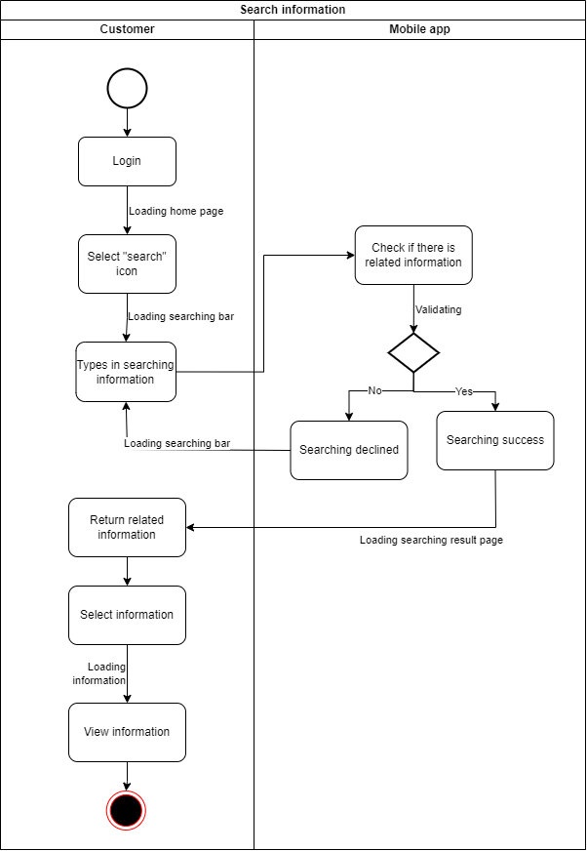

## **4.2 Online Booking**

### **4.2.1 Online Booking**

**a) Use case diagram**

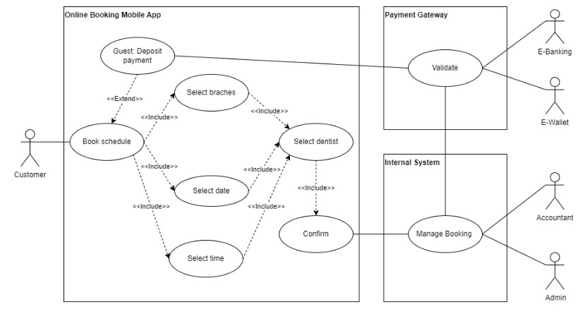

**b) Specification**

|  |  |
| --- | --- |
| **UC Name** | Online Booking |
| **Actor** | Customers, admin |
| **Description** | I want to book an appointment online at HL’s dental clinic |
| **Priority** | High |
| **Trigger** | Open app and click “Book schedule” |
| **Pre-Condition** | 1. Customer has a verified account  2. Customer logged in personal account successfully  3. Customer’s device have been connected in internet already |
| **Post Condition** | * Customer created the appointment successfully * System has noted the successful customer’s booking in schedule |
| **Basic Flow** | 1. Customer select to create booking an appointment  2. Customer select date, time and doctors  3. Customer confirm information  4. The system validates the booking information successfully  5. The system notifies the successful transaction on the display screen for customer |
| **Alternative Flow** | 3a. Customer with type “Guest” account choose payment by e-banking  3a1. System switches to the payment screen of the bank selected by the user  3a2. User fill information and select to pay  3a3. The amount has been confirmed by the bank  3a4. The transaction is successful  *Use case continues to step 3*  3b. Customer with type guest account choose payment by e-wallet  3b1. System switches to the payment screen of e-wallet  3b2. User fill information and select to pay  3b3. The system confirms the payment has been received  3b4. The transaction is successful  *Use case continues to step 3* |
| **Exception Flow** | 3a3. The payment has been invalid  3a3.1. User choose cancel payment  *Use case stop*  3a3. The payment has been invalid  3a3.1. User choose cancel payment  *Use case stop*  2. The system confirm member account  *Use case continues to step4* |
| **Business Rule** |  |
| **Non-Functional Requirements** | NFR3: timeout for payment information within 3 minutes |

**c) Activity Diagram**

**d) State Machine Diagram**

### **4.2.2 Online Booking Guest - Payment for Reserve**

**a) Use case diagram**

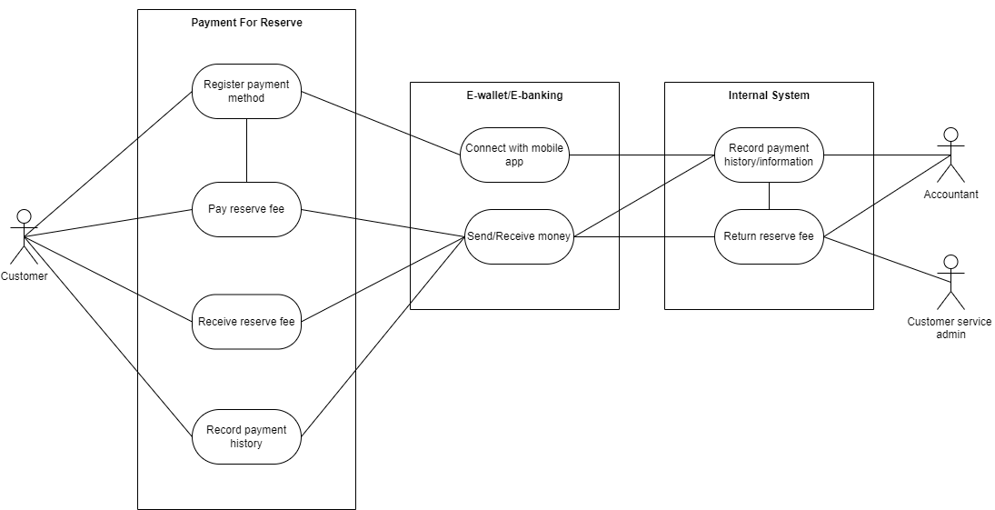

**b) Specification**

|  |  |
| --- | --- |
| **UC Name** | Pay reserve fee |
| **Actor** | Customer, Accountant, Internal System, E-wallet/E-banking system |
| **Description** | As a customer, I want to pay reserve fee to ensure that I have an appointment |
| **Priority** | High |
| **Trigger** | Customer clicks “finish booking appointment” button |
| **Pre-Condition** | 1. Customer has a valid account  2. Customer is guest account  3. Customer opens the “Book appointment” page  4. Customer filled in booking appointment information |
| **Post Condition** | 1. Customer successfully pays reserve fee  2. Customer successfully books an appointment  3. System goes back to main page |
| **Basic Flow** | 1. Customer clicks "finish booking appointment” button  2. System returns with “pay reserve fee” page  3. Customer selects payment method with e-wallet  4. Customer clicks “Pay” button  5. System returns with loading screen  6. E-wallet/E-banking finishes transferring money  7. System returns with “Successfully book schedule” message  8. System updated payment history and sends information to internal system  System goes back to main page |
| **Alternative Flow** | 3a. Customer registers payment method with e-wallet  3a1. System moves to the e-wallet app  3a2. Customer clicks “verify the connection”  3a3. System moves back to the mobile app  3a4. Customer selects payment method with e-wallet  Use Case continues at step 4.  3b. Customer selects payment method with card  *Use Case continues at step 4.*  3c. Customer registers payment method with card  3c1. System opens the “card information” page  3c2. Customer provides card information  3c3. Customer selects payment method with card  *Use Case continues at step 7.*  3d. Customer selects payment method  3d1. System notifies “Not enough available balance”  3d2. Customer selects another payment method  Use Case continues at step 4. |
| **Exception Flow** | 3e. Customer does not have enough balance  Use Case stop.  4a. Customer clicks “Return” button  4a1. System sends confirmation message  4a2. Customer agrees to stop and returns to the main page  Use Case stop.  6a. E-wallet/E-banking fails to transfer money  Use Case stop. |
| **Business Rule** | BR-3. For each e-wallet, each account could only connect 1 personal e-wallet account.  BR-4. Time out for each transaction within 3 minutes BR-5. If user “Guest” account type, then cancel before 3 days on schedules can be receive refund from system. Cancel after 3 days on schedules not receive refund. |
| **Non-Functional Requirements** | NFR-4. Payment will be verified within 30 second |

**c) Activity Diagram**

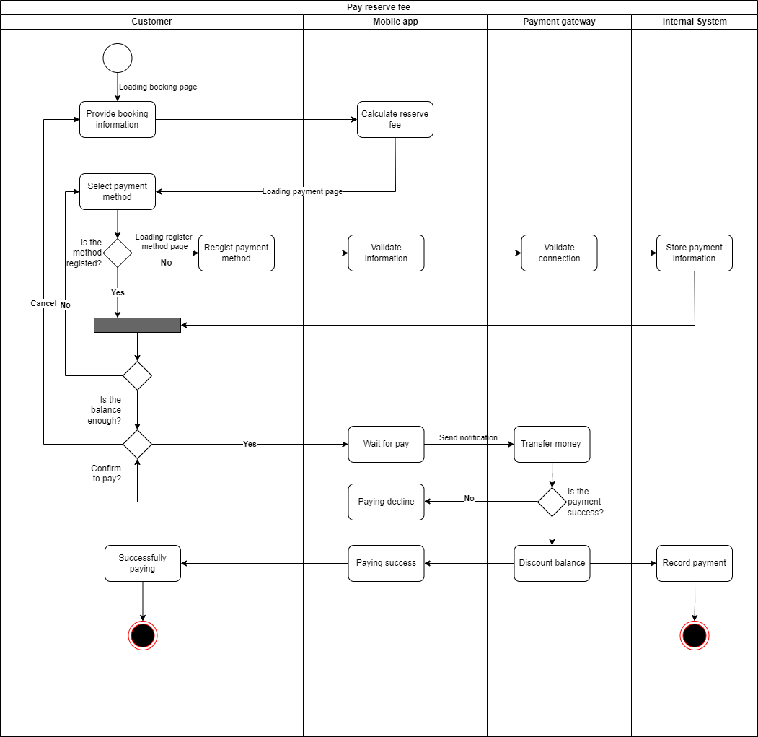

## **4.3 Manage Schedule**

**a) Use case diagram**

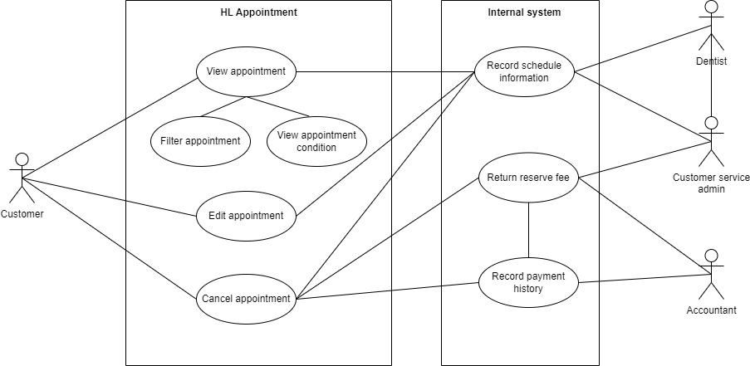

**b) Specification**

|  |  |
| --- | --- |
| **UC Name** | Edit appointment |
| **Actor** | Customers, Internal system, Customer service admin, Dentist |
| **Description** | As a customer, I want to edit appointment to adjust the schedule when I’m busy |
| **Priority** | High |
| **Trigger** | Customer clicks on edit option of the appointment |
| **Pre-Condition** | 1. Customer has logged in a valid account 2. Customer has had at least 1 appointment booked |
| **Post Condition** | 1. The appointment is updated 2. System sends “Successfully edit appointment” notification to customer |
| **Basic Flow** | 1. Customer clicks on edit option of the appointment 2. System opens edit appointment page 3. Customer adjusts the schedule (time, date, dentist, branch) 4. Customer clicks “Save the change” button 5. System goes back to schedule page 6. System changes the appointment status into “Need to check” and updates on internal system 7. Customer service admin calls to verify with customer and dentist-in-charge 8. Customer service admin verifies the information and updates appointment status into “Verified” 9. System updates new version of the appointment   10. System sends “Successfully edit appointment” notification to customer |
| **Alternative Flow** | 4a. Customer clicks “Cancel” button  Use Case backs to step 3 |
| **Exception Flow** | 4a. Customer clicks “Cancel” button  4a1. System goes back to schedule page  Use Case stop.  8a. Customer service admin refuses the information and updates appointment status into “Failed”  8a1. System sends “Unsuccessfully edit appointment” notification to customer  Use Case stop. |
| **Business Rule** | 1. Customers must edit appointment at least X hours before the schedule they set 2. Only members with registered account could perform this function |
| **Non-Functional Requirements** |  |

|  |  |
| --- | --- |
| **UC Name** | Cancel appointment |
| **Actor** | Customers, Internal system, Customer service admin, Dentist, Accountant |
| **Description** | As a customer, I want to cancel appointment to avoid no shows and get a refund for my prepayment |
| **Priority** | High |
| **Trigger** | Customer clicks “Cancel appointment” option of the appointment |
| **Pre-Condition** | 1. Customer has logged in a valid account  2. Customer has at least 1 appointment booked |
| **Post Condition** | 1. The appointment status is updated into “Cancel”  2. System sends “Successfully cancel appointment” notification |
| **Basic Flow** | 1. Customer clicks “Cancel appointment” option of the appointment 2. System opens the reason form 3. Customers provide reason to cancel the appointment 4. System sends notification if customer truly wants to cancel the appointment 5. Customer selects “Yes” 6. System goes back to schedule page 7. System changes the appointment status into “Cancel” and updates on internal system 8. Customer service admin checks if customer is qualified for refunding and makes refund process if needed 9. System sends “Successfully cancel appointment” notification |
| **Alternative Flow** | 1a. Customer calls hotline to cancel the schedule  1a1. Customer service admin updates “Cancel” status on internal system  1a2. System changes the appointment status into “Cancel”  Use Case continues at step 8. |
| **Exception Flow** | 5a. Customer selects “Return”  Use Case stop. |
| **Business Rule** | 1. Customers must cancel appointments at least X hours before the schedule they set for 100% refund. If not, there will be a penalty or no refund. 2. Only members with registered account could perform this function |
| **Non-Functional Requirements** |  |

**c) Activity Diagram**

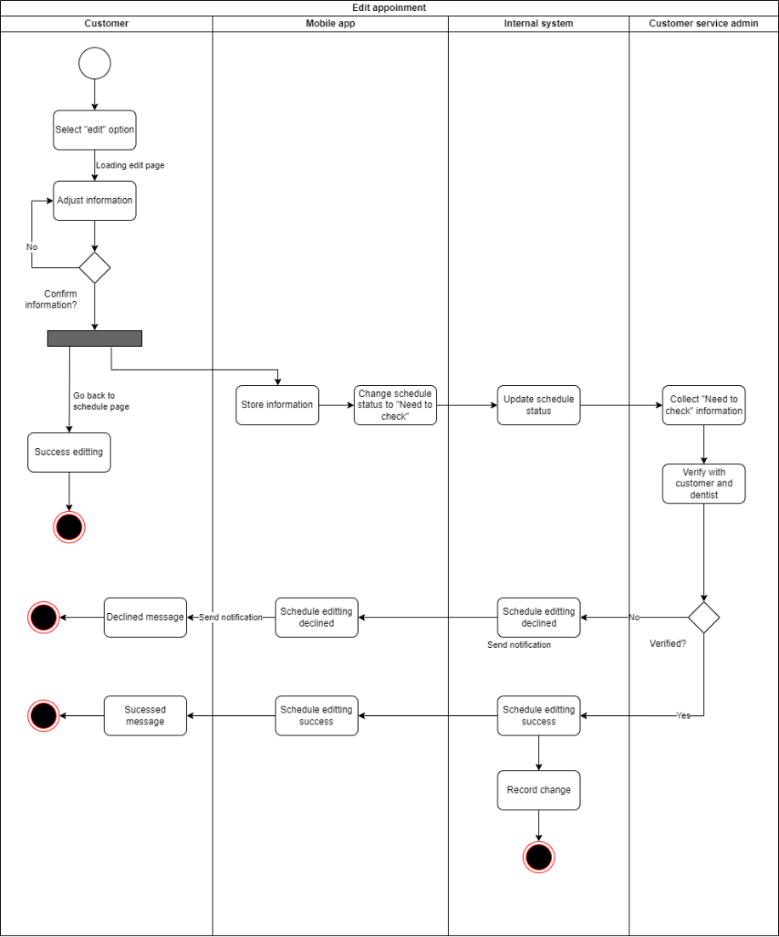

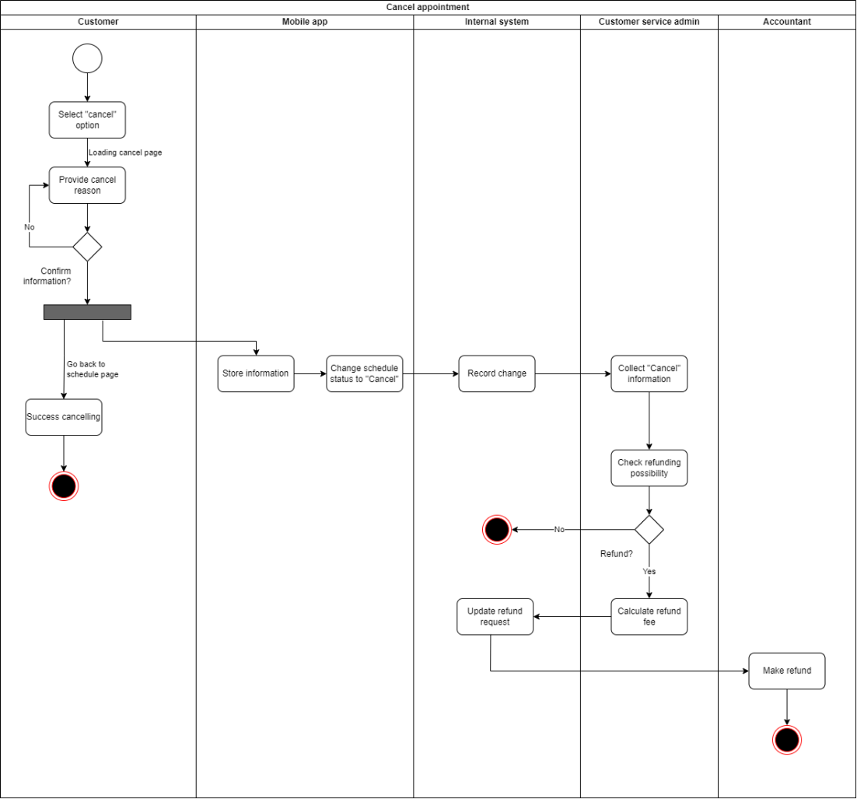

## **4.4 Treatment History**

**a) Use case diagram**

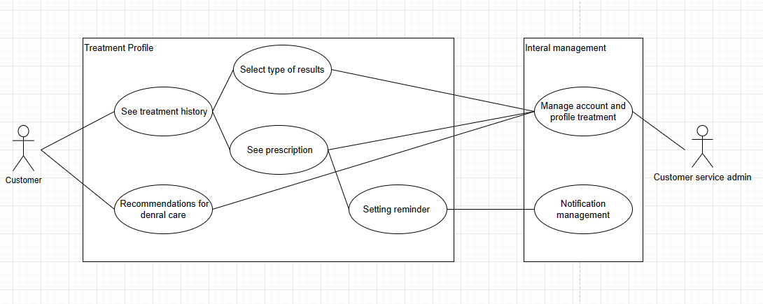

**b) Specification**

|  |  |
| --- | --- |
| **UC Name** | See treatment history |
| **Actor** | Customers, Customer service admin |
| **Description** | As a customer, I want to know the results of my medical exams |
| **Priority** | High |
| **Trigger** | Customer clicks “Treatment history” button |
| **Pre-Condition** | 1. Customer has logged in personal account. 2. Patients has been treated before at dental 3. The patient’s medical history has been updated on the system |
| **Post Condition** | 1. Treatment can see information about treatment history |
| **Basic Flow** | 1. Customer clicks “treatment history” button 2. Customers choose the type of viewing time. 3. Customers select the button “examination results” to see specific results of an examination. 4. Customers choose the type to view medical examination results. 5. The system returns the results that the customer wants to see. 6. Customer views the examination results |
| **Alternative Flow** | 2a. Customers choose to view medical history by month.  *Use Case continue at step 3.*  2b. Customers choose to view medical history by year.  *Use Case continue at step 3.*  2c. Customers choose to see all medical history.  *Use Case continue at step 3.*  4a. Customers choose to see test results.  *Use Case continue at step 5.*  4b. Customers choose to see image results.  *Use Case continue at step 5.* |
| **Exception Flow** | 6a. User selects “home page back” button  *The system returns to the main screen* |
| **Business Rule** |  |
| **Non-Functional Requirements** |  |

## **4.5 Medicine bills**

**a) Use case diagram**



**b) Specification**

|  |  |
| --- | --- |
| **UC Name** | See Medicine bills |
| **Actor** | Customers, Customer service admin |
| **Description** | As a customer, I want to know the results of my medical exams |
| **Priority** | High |
| **Trigger** | Customer clicks “Prescription” button |
| **Pre-Condition** | 1. Customer has logged in personal account. 2. Patients has been treated before at dental 3. The patient’s medical history has been updated on the system |
| **Post Condition** | 1. Treatment can see information about Prescription |
| **Basic Flow** | 1. Customer clicks “Prescription” button 2. Customers choose the type of viewing time. 3. Customers select the button “examination results” to see specific results of an examination. 4. Customers choose the type to view medical examination results. 5. The system returns the results that the customer wants to see. 6. Customer views the examination results |
| **Alternative Flow** | 2a. Customers choose to view medical history by month.  *Use Case continue at step 3.*  2b. Customers choose to view medical history by year.  *Use Case continue at step 3.*  2c. Customers choose to see all medical history.  *Use Case continue at step 3.*  4a. Customers choose to see test results.  *Use Case continue at step 5.*  4b. Customers choose to see image results.  *Use Case continue at step 5.* |
| **Exception Flow** | 6a. User selects “home page back” button  *The system returns to the main screen* |
| **Business Rule** |  |
| **Non-Functional Requirements** |  |

## **4.7 Customer Service – Feedback**

**a) Use case diagram**

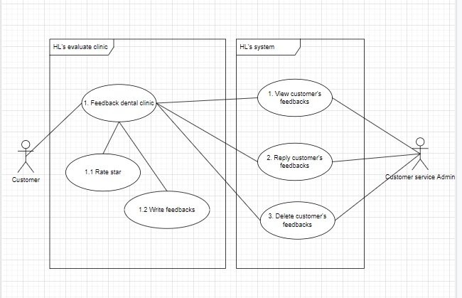

**b) Specification**

|  |  |
| --- | --- |
| **UC Name** | Feedback HL’s dental clinic |
| **Actor** | Customers, Customer service admin |
| **Description** | As a customer, I want to evaluate HL’s dental clinic to improve service quality |
| **Priority** | Low |
| **Trigger** | Customer clicks “feedback” button on navigation bar |
| **Pre-Condition** | 1. Customer has account and already logged in the mobile app 2. Customer used dental service at clinic 3. The app must prompt customers to evaluate recent visits to dental clinics. |
| **Post Condition** | Customer receives message “submit feedback successfully” |
| **Basic Flow** | 1. Customer clicks the “feedback” button 2. The app displays all information that customers need to feedback 3. Customer provides a rating and feedback for the material facilities and professional quality. 4. Customer clicks submit feedback and receives message feedback successfully 5. Customer service admin receives the customer’s evaluation and can see it |
| **Alternative Flow** | 1a. Customer decides to not provide feedback currently  1a1. The app prompts the customer to provide feedback later.  *Use case continue at step 2*  3a. The customer provides a rating and feedback for only one aspect of the dental clinic, such as material facilities or professional quality.  *Use Case continue at step 4* |
| **Exception Flow** | 3b. Customer clicks “feedback later”  *Use Case stop.*  4a. The customer encounters an error while providing the feedback, such as an issue with the internet connection.  4b. The app displays an error message and prompts the customer to try again later.  *Use Case stop.* |
| **Business Rule** | 1. The customer's evaluation must meet the app's content policy and cannot contain any inappropriate language or personal information. 2. Customer only send feedback within 30 days. |
| **Non-Functional Requirements** | 1. Security: The app must ensure that the customer's personal information is protected and not shared with any third parties. |

## **4.8 Customer Service – Chat/Call with us**

**a) Use case diagram**

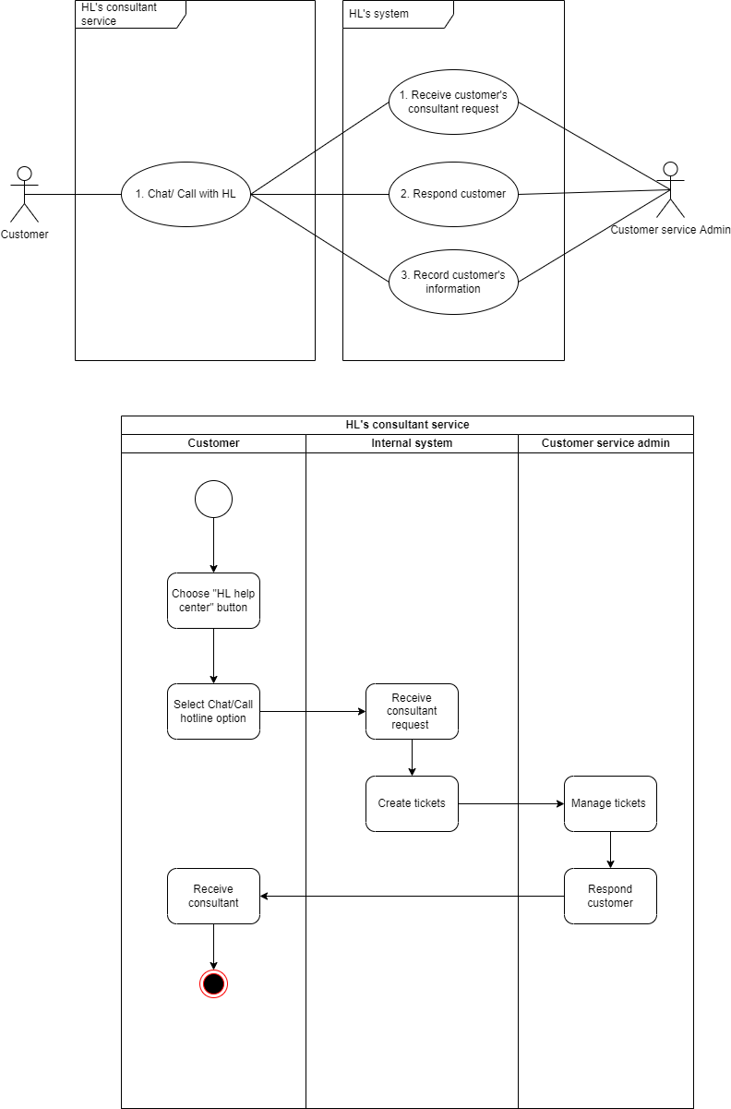

**b) Specification**

|  |  |
| --- | --- |
| **UC Name** | Customer service |
| **Actor** | Customers, Customer service admin |
| **Description** | As a customer, I want to connect directly with customer service of dental clinic to find support |
| **Priority** | High |
| **Trigger** | Customers click “HL help centre” button on navigation bar |
| **Pre-Condition** | 1. Customer has account and already logged in the mobile app 2. Customer has used dental service at clinic before |
| **Post Condition** | 1. Customer receives advice and recommendations from customer services |
| **Basic Flow** | 1. Customer clicks “HL help centre” button on navigation bar. 2. The app displays three option “Chat with us”, “call hotline”, and “I’ll be back later” 3. Customer provide their needs 4. Customer service admin gives recommendations. |
| **Alternative Flow** | 2a. Customer chooses “send messages to us”  *Use case continues at step 3.*  2b. Customer chooses “call with us”  *Use case continues at step 3.* |
| **Exception Flow** | 2b. Customer chooses “I’ll be back later”  *Use case stops.* |
| **Business Rule** |  |
| **Non-Functional Requirements** | Security: Customers’ personal information must be protected. |

## **4.9 Account**

### **4.9.1 Account – Sign Up/Sign In**

**a) Use case diagram**

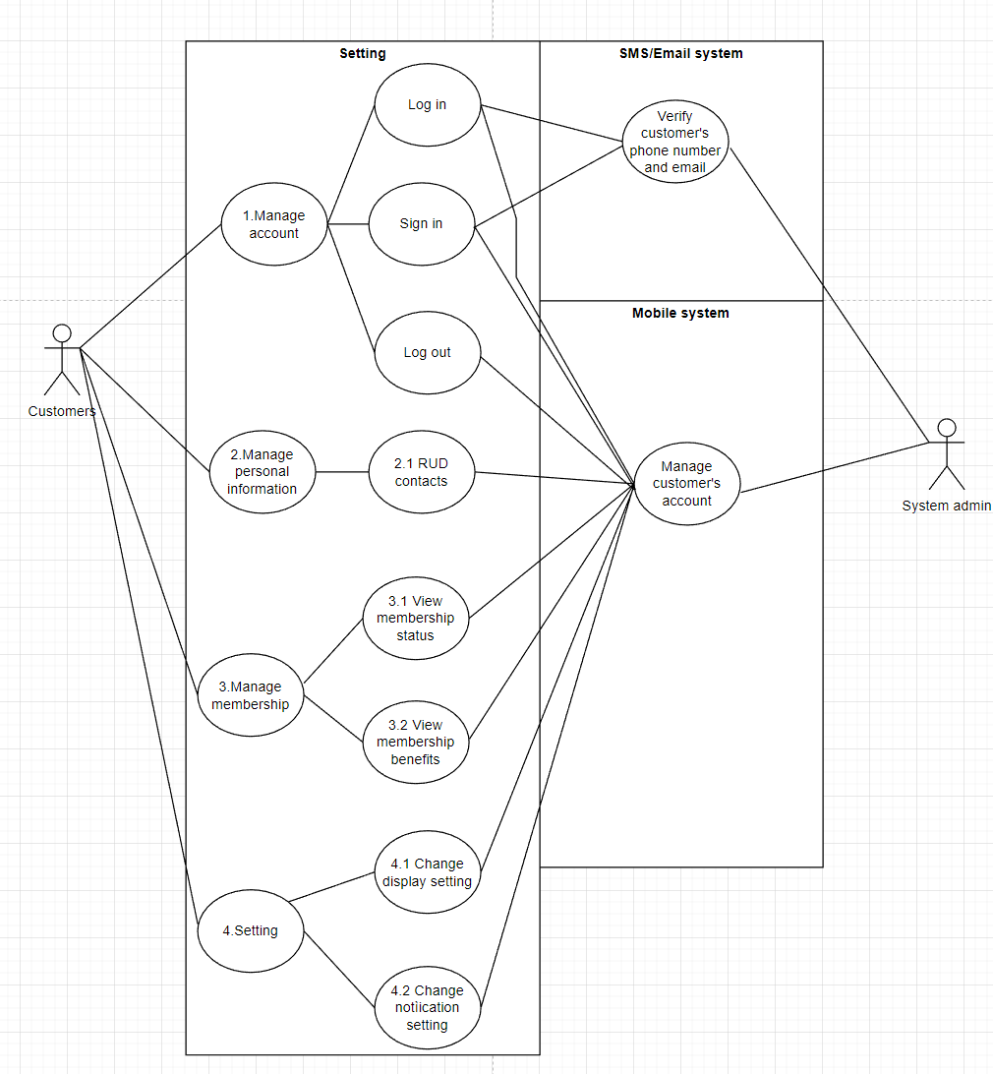

**b) Specification**

|  |  |
| --- | --- |
| **UC ID** | UC |
| **UC Name** | Sign in |
| **Actor** | Customers, Google, phone |
| **Description** | As a customer, I want to sign in the app, so that I can use HL dental services |
| **Priority** | High |
| **Trigger** | Customer clicks in the app and the app display signing in page |
| **Pre-Condition** | 1. Customers already have an account  2. App has not been signed in |
| **Post Condition** | Customers sign in the app successfully |
| **Basic Flow** | 1. Customers clicks in the app 2. Customers choose the function to sign in through personal phone number 3. Customers fill out account, password and click sign in 4. System receives request to sign in and check user’s account authorization 5. System authorizes user to sign in 6. System record user sign in activity in the Activity Log 7. Users sign in successfully |
| **Alternative Flow** | 2a1 Customers choose the function to sign in through email  2a2 System switch to Email sign in page  2a3 Users fill out account, password and click sign in  2a4 System receives request to sign in and check user’s account authorization  2a5 System authorizes user to sign in  *Use case continues at step 6* |
| **Exception Flow** | 1b1 Users log out of the app  *Use case stops*  2b1 Users choose to renew their password  *Use case continues from Basic flow 2*  2c1 Users choose to change their password  *Use case continues from Basic flow 2*  5d1 System does not authorizes user to sign in  5d2 Users stop sign in process  5d3 Users log out of the app  *Use case stops* |
| **Business Rule** | BR1.1-1: If users fill incorrect sign ininformation for over 3 times consecutively, the account will be locked for 5 minutes |

### **4.9.2 Account – change password**

|  |  |
| --- | --- |
| **UC ID** | UC |
| **UC Name** | Change password |
| **Actor** | Customer, mobile app |
| **Description** | As a customer, I want to change my password, so that I can change my password to another one |
| **Priority** | Medium |
| **Trigger** | Customers click into the “Change password” button in “Setting” section |
| **Pre-Condition** | - Customers logged in HL Dental mobile app |
| **Post Condition** | Customers successfully changed password |
| **Basic Flow** | 1. Customers click into the “Setting” button in the navigation bar 2. Customers choose “Change password” buttong 3. Customers fill out the following information  * Current password * New password and confirm it.  1. Mobile app system verifies the new password 2. Mobile app system authorized the customers to changed password 3. Mobile app system record customers action in the Activity log 4. Mobile app system displays “Change password successfully” text 5. Customers successfully changed their password |
| **Alternative Flow** | 5a1 Mobile app system decline the new password  5a2 Mobile app system displays “Type in another password”  5a3 Customers type in another password  *USe case continues at UC 6* |
| **Exception Flow** | 3a1 Customers click “Exit” button  3a2 Mobile app system displayes “Information will not be saved”  3a3 Customers click “Exit” button  3a4 Customers successfully exit out of “Changing password” page  *Use case stop*  5a1 Mobile app system decline the new password  5a2 Mobile app system displays “Type in another password”  5a3 Customers click “Exit” button  5a4 Mobile app system displayes “Information will not be saved”  5a5 Customers click “Exit” button  5a6 Customers successfully exit out of “Changing password” page  *Use case stop* |
| **Business Rule** | BR 1-1: Password must contain at least 6 characters  BR 1-2: No space  BR 1-3: Not a duplicate of the current password |

### **4.9.3 Account – Forget password**

|  |  |
| --- | --- |
| **UC ID** | UC |
| **UC Name** | Renew password when customers forget password |
| **Actor** | Customers, mobile app, SMS, email |
| **Description** | As a customer, I want to renew my password, so that I can change to another password in case I forget my current password |
| **Priority** | High |
| **Trigger** | Customers click into the “Forget password” in the signing in screen |
| **Pre-Condition** | Customers have a HL dental app account  Customers are not logged in the dental app |
| **Post Condition** | Customers successfully renew their password |
| **Basic Flow** | 1. Customers click the “Forget password” in the signing in screen 2. Mobile app display to 2 options for customers to choose as a method to renew their password   Option 1: Phone number  Option 2: Email   1. Customers choose “Phone number” option 2. Customers fill in their mobile phone number 3. Mobile app system received request and send request to the SMS system 4. SMS system send an OTP to customer’s phone 5. Customers fill in the OTP 6. Mobile app verified the OTP 7. Customers fill in their new password 8. Mobile app verify their password 9. Mobile app system authorized the customers to changed password 10. Mobile app system record customers action in the Activity log 11. Mobile app system displays “Change password successfully” text 12. Customers successfully changed their password |
| **Alternative Flow** | 3a1 Customers choose “Email” option  3a2 Customers fill in their mobile phone number  3a3 Mobile app system received request and send request to the email system  3a4 Email system send an OTP to customer’s mail  *Use case continues at Use case 7*  8a1 Mobile app decline the OTP  8a2 Customers choose “Re send” button  8a3 Email/SMS system re send the OTP  *Use case continues at Use case 7*  10a1 Mobile app system decline the new password  10a2 Mobile app system displays “Type in another password”  10a3 Customers type in another password  10a4 Mobile app verify their password  *USe case continues at UC 11* |
| **Exception Flow** | 3a1 Customers click “Exit” button  3a2 Mobile app system displayes “Information will not be saved”  3a3 Customers click “Exit” button  3a4 Customers successfully exit out of “Forget password” page  *Use case stop*  7a1 Mobile app system decline the OTP  7a2 Customers click “Exit” button  7a3 Mobile app system displayes “Information will not be saved”  7a4 Customers click “Exit” button  7a5 Customers successfully exit out of “Changing password” page  *Use case stop*  10a1 Mobile app system decline the new password  10a2 Mobile app system displays “Type in another password”  10a3 Customers click “Exit” button  10a4 Mobile app system displayes “Information will not be saved”  10a5 Customers click “Exit” button  10a6 Customers successfully exit out of “Changing password” page  *Use case stop* |
| **Business Rule** | BR 1-1: Password must contain at least 6 characters  BR 1-2: No space  BR 1-3: Not a duplicate of the current password |

### **4.9.4 Account – Membership**

**a) Use case diagram**

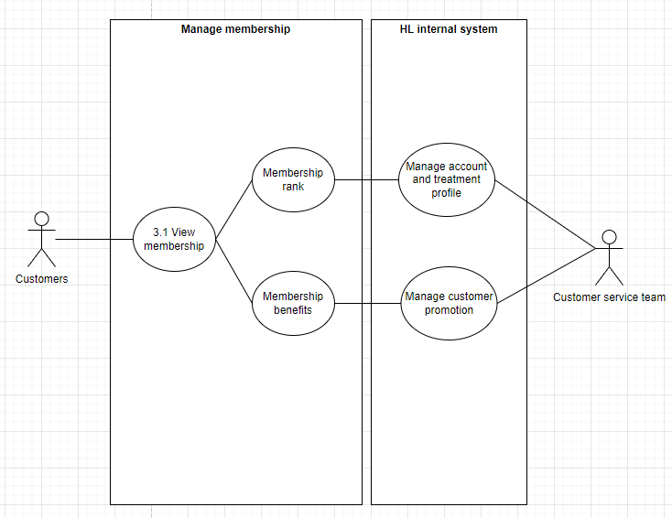

**b) Specification**

|  |  |
| --- | --- |
| **UC ID** | UC |
| **UC Name** | View membership status |
| **Actor** | Customers, customer service team |
| **Description** | As a customer, I want to view my membership status, so that To know which level of membership I have |
| **Priority** | Low |
| **Trigger** | Customer clicks the “Membership” button in the "Account” section |
| **Pre-Condition** | * Customers logged in HL Dental mobile app |
| **Post Condition** | * Customer able to view all of the information relevant to their membership status |
| **Basic Flow** | 1. Customers clicks the “Account” button on navigation bar 2. Customers choose “Membership” section 3. System fetch customer’s information from database 4. System displays following information  * Customer’s membership rank * Information on how to rank up * Benefits  1. Customers successfully view the relevant information |
| **Alternative Flow** |  |
| **Exception Flow** | 3.a Customer clicks “Back” button  Use Case stop |
| **Business Rule** |  |

**c) Activity diagram**

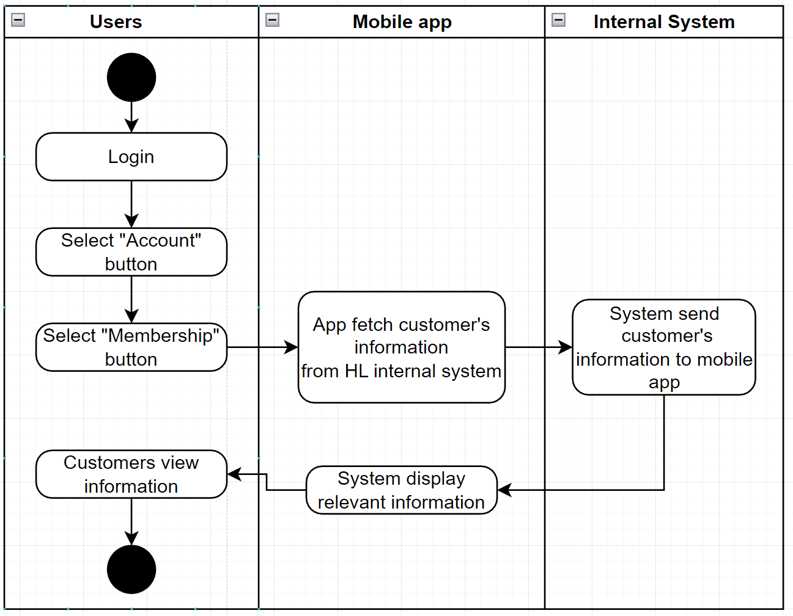

### **4.9.5 Account – Change profile information**

**a) Use case diagram**



**b) Specification**

|  |  |
| --- | --- |
| **UC ID** | UC |
| **UC Name** | Change profile information |
| **Actor** | Customers, mobile app |
| **Description** | As a customer, I want to change my profile information, so that it would match my current information |
| **Priority** | Low |
| **Trigger** | Customers click into the “Edit” icon in the profile page |
| **Pre-Condition** | * Customers logged in HL Dental mobile app |
| **Post Condition** | Customers successfully change their profile information |
| **Basic Flow** | 1. Customers click into the “Setting” section in the navigation bar 2. Customers click into the “Profile” button 3. Customers click into the “Edit” icon 4. Customers fill in the information they want to change 5. Mobile app system verify the information 6. Mobile authorized the information 7. Mobile app display “Change successfully” 8. Customers successfully changed their profile information |
| **Alternative Flow** | 6a1 Mobile app do not authorized the information  6a2 Customers re-check and fill the information  Use case continues at use case 5 |
| **Exception Flow** | 4a1 Customers click “Exit” button  Use case stop  5a1 Mobile app system do not authorized the information  5a2 Customers click “Exit” button  5a3 Mobile app displays “Information will not be recorded”  5a4 Customers click “Exit”  Use case stop |
| **Business Rule** | BR 1-1: Phone number character must be at 10 characters  BR 1-2: Birthday must be before current day  BR 1-3: Birthday must comply to the format DD/MM/YY |

### **4.9.6 Account – Turn on/off notification**

**a) Use case diagram**



**b) Specification**

|  |  |
| --- | --- |
| **UC ID** | UC |
| **UC Name** | Turn on/off the notification |
| **Actor** | Customers, mobile app |
| **Description** | As a customer, I want to change my notification setting, so that it would suit my preference |
| **Priority** | Medium |
| **Trigger** | Customers click into the “Notification” in the “Setting” section |
| **Pre-Condition** | * Customers logged in HL Dental mobile app |
| **Post Condition** | Customers successfully changed the notification in accordance with their preference |
| **Basic Flow** | 1. Customers click into “Setting” section in the navigation bar 2. Customers clicks into the “Notification” 3. Mobile app displays the following information  * Overall notification * Schedule notifcaion * News notification * Promotion notification * Message notification  1. Customers change the notification according to their preference in desired information 2. Mobile mobile app authorized the new information 3. Mobile app res |
| **Alternative Flow** |  |
| **Exception Flow** | 5a1 Customers click “Exit” button  Use case stop |
| **Business Rule** |  |